**Experiment No. 1**

Installation of Xampp

1) Download Xampp using wget command

wget <http://sourceforge.net/projects/xamp/files/XAMPP%20Linux/5.6.3/xampp-linux-5.6.3-0installer.run/download>

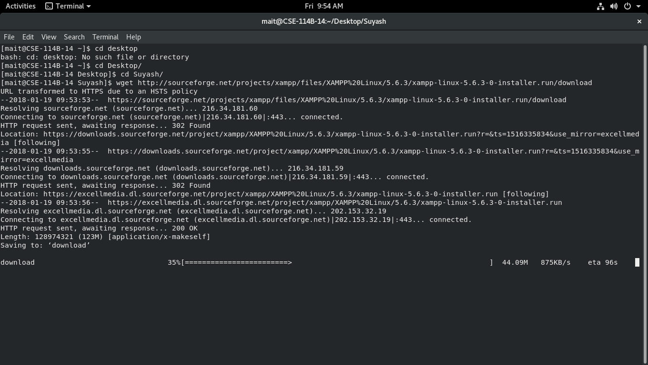

During Download

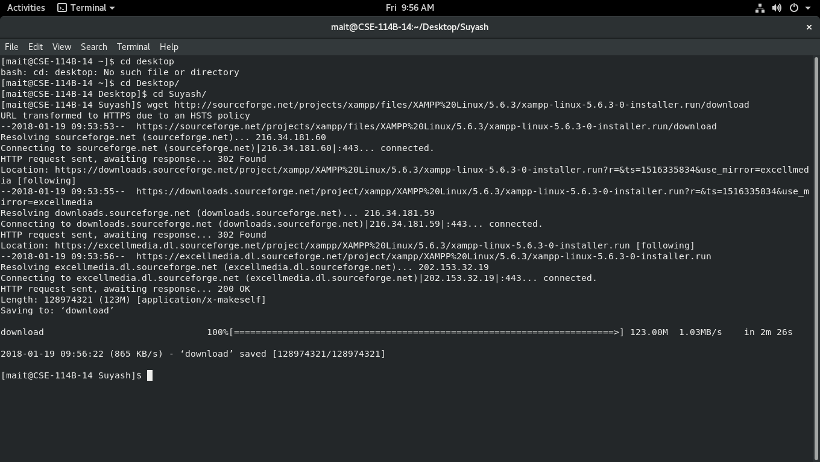

After Download

2) The Xampp file will be downloaded to the **Downloads** Folder. Open the Terminal. Type the following command in terminal to open file location

**cd ~/Downloads**

3) Run the following command to make it executable

**chmod +x xampp-linux-x64-7.2.1-0-installer.run**

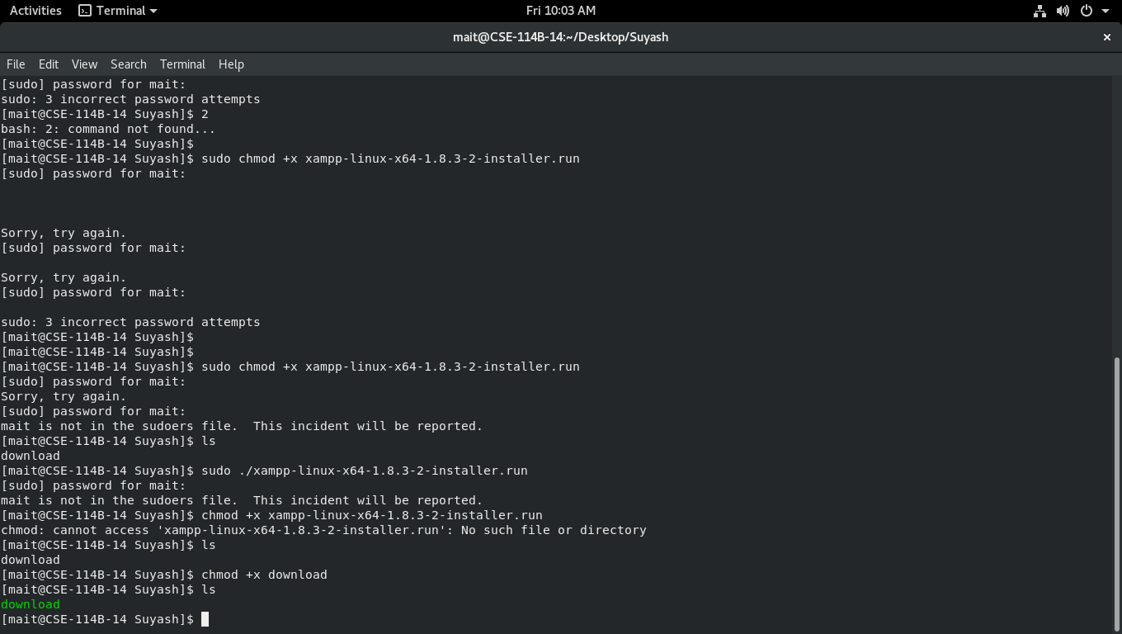

4) To Install Xampp  ,  Run the below command  in terminal

**./xampp-linux-x64-7.2.1-0-installer.run**

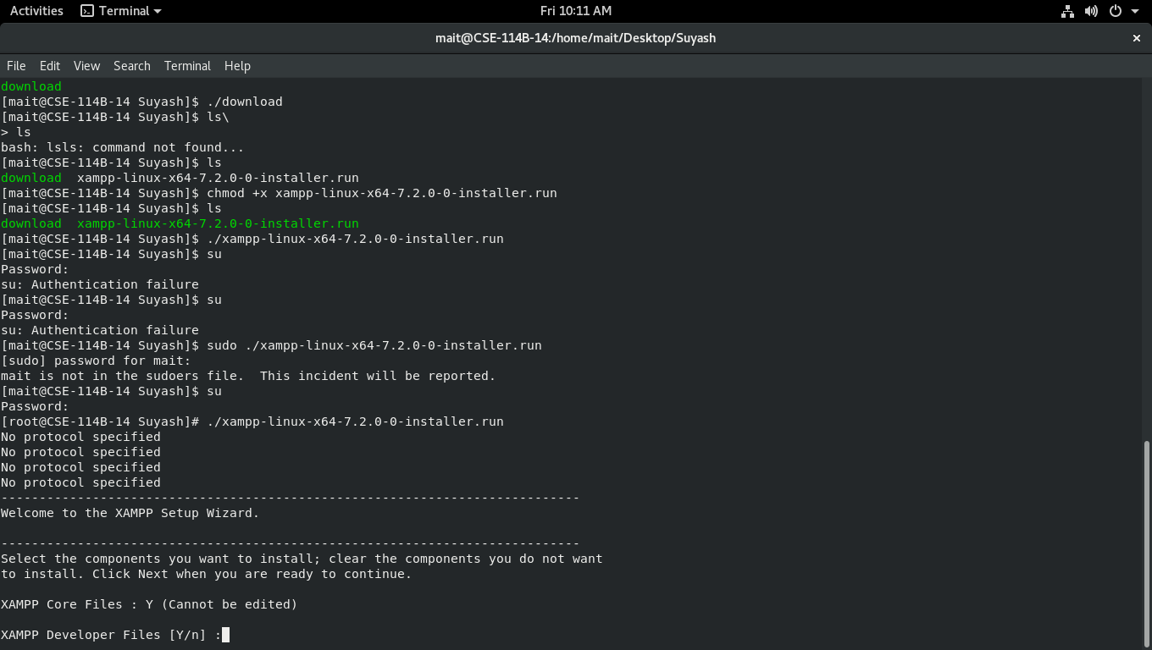

Asking whether or not to download XAMPP developer files

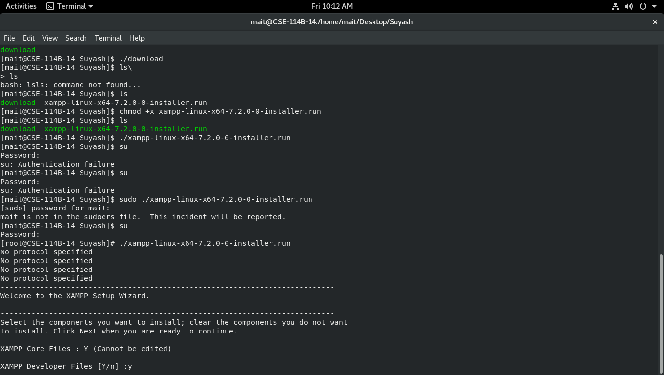

After giving permission to download the XAMPP developer files

5) After Few steps, XAMPP installation starts automatically . Once installaition is done, It will be installed in **/opt/lampp** directory

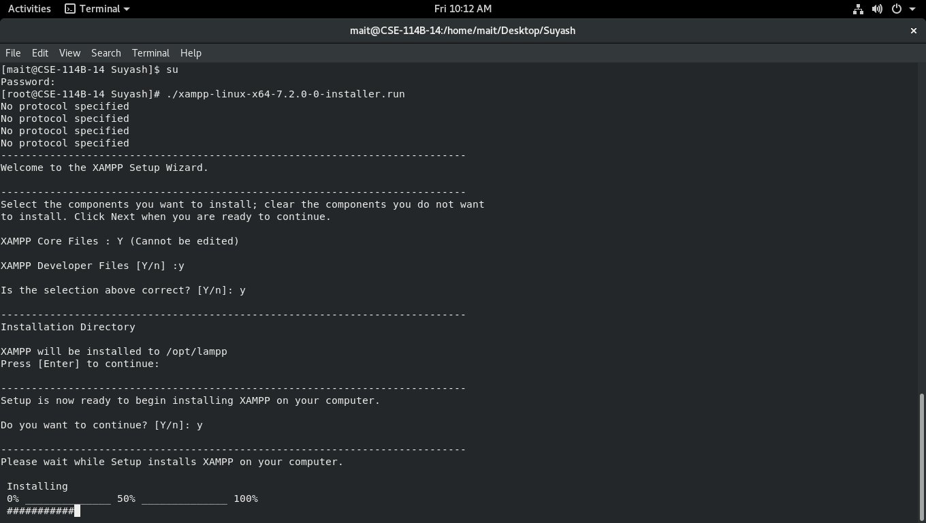

During Installation

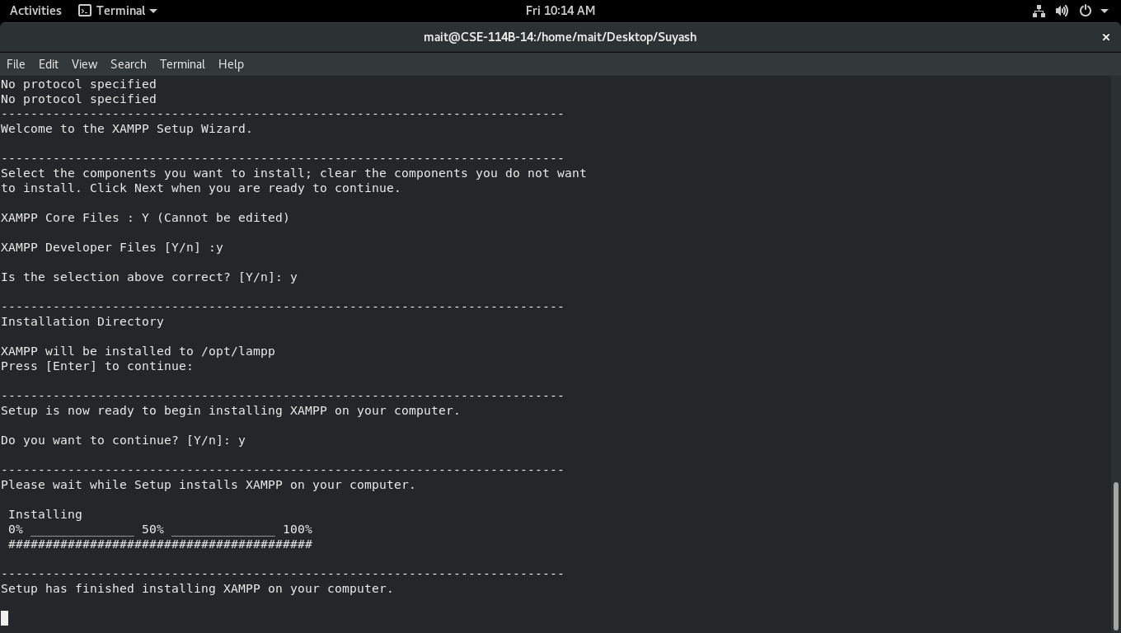

After Installation